|  |  |  |
| --- | --- | --- |
|  |  |  |
|  |  |  |
|  |  |  |
|  |  |  |
|  |  |  |
|  |  |  |
|  |  |  |
|  |  |  |

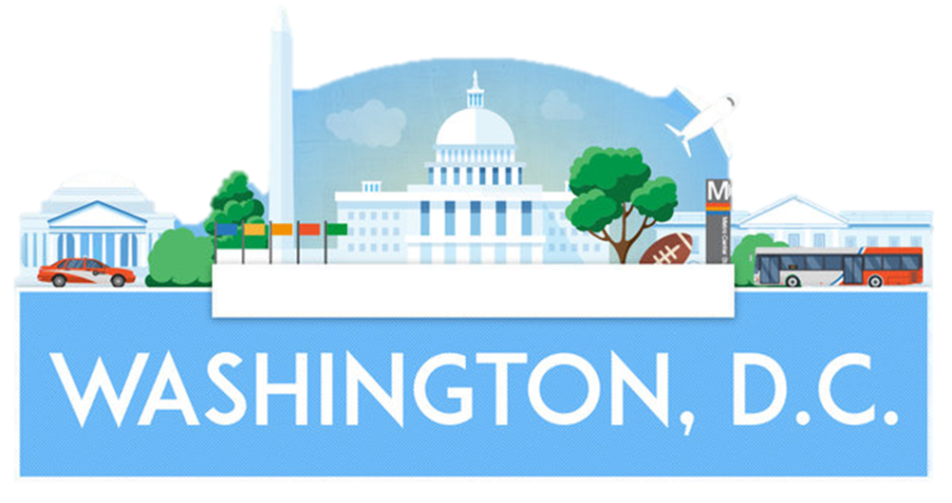

**1. Watch the** [**video**](https://www.youtube.com/watch?v=7dilTLvbHxc) **and identify the attractions in Washington D.C.**

Vietnam Veterans Memorial – M. L. King Memorial - Smithsonian Institution – Washington Monument – Lincoln Memorial – The Capitol - Reflecting Pool – National Air and Space Museum – The White House – National Cathedral – International Spy Museum – Jefferson Memorial

**2. Connect the right attraction with its definition.**

a) Vietnam Veterans Memorial ____ world's largest museum complex

b) Washington Monument ____ residence of the US president

c) Lincoln Memorial ____ dedicated to soldiers in the Vietnam war

d) M. L. King Memorial ____ religious place where services are held

e) Smithsonian Institution ____ dedicated to Jefferson, 3rd US President

f) The White House ____ the Congress meets here.

g) National Cathedral ____ Washington monument can be seen in it

h) Reflecting Pool ____ dedicated to the 16th US President.

i) Jefferson Memorial ____ a monument dedicated to the 1st President

j) The Capitol ____ dedicated to the fighter against racism

**3. Mark Washington, D.C. on the USA map and learn more about the city by looking at its famous building on Google Maps -** [**Washington, D.C. Google Maps**](https://earth.google.com/web/@0,0,0a,22251752.77375655d,35y,0h,0t,0r?authuser=0)

**.**

